**Proposal for**

SUMMER UNDERGRADUATE RESEARCH AWARD (SURA) – 2018

## Design of an Integrated Semi-Autonomous

## Regular Health Monitoring Machine



**Kshitij Gupta Tanmay Goyal**

Dept. of Mechanical Eng. Dept. of Mechanical Eng.

2016ME20760 2016ME20757

Contact No: 07827151976 Contact No: 09821898027

CGPA: 9.17 CGPA: 8.64

**FACILITATOR**

Prof. Devendra Kumar Dubey  
Assistant Professor   
Department of Mechanical Engineering   
Indian Institute of Technology Delhi

**Prof. S.K. Saha IRD Unit**

**Head of Department IIT Delhi**

**Department of Mechanical Engineering  
IIT Delhi**

**INTRODUCTION**

Many people in poorer societies suffer because of non-availability of simple and standard technologies to the people at the grassroots level. Delivery of healthcare to the rural population is an area of concern. There is a marked difference in the healthcare scenario between the rural/remote areas and urban areas. It is observed that compared to urban areas, in rural areas, doctor to population ratio is lower by six times, hospital beds to population ratio is lower by 15 times and per capita public expenditure on health is seven times lower. A large number of health facilities have been set up by the government but still, the numbers are not sufficient to serve the entire rural population. Many existing facilities lack resources and/or trained medical professionals, which results in non-availability of quality healthcare to the rural population. Villagers end up travelling large distances to towns or cities to get medical services.

In a study done by Indian Space Research Organisation (ISRO) on the utilisation of the Primary Health Centres (PHCs), 47 percent of the population depends upon the government PHC for their healthcare needs. Also, the same study points out that 14 percent of the patients travel 9-15 Km, 31 percent travel 35-45 Km and a huge 55 percent travel more than 55 Km for accessing secondary or tertiary services. It results in extra expenditure on travel and loss of pay for the patient as well the person accompanying the patient.

Thus the device that we intend to create can give a basic overview of patient’s health by measuring parameters like ECG, Non-invasive Blood Pressure, Glucose level, Temperature, Oxygen Saturation levels, Heart rate, Pulse Rate and other required information showing the dangers to health and how they can be treated primarily. It can maintain health records and compare them periodically for health comparison.

**OBJECTIVE**

1. To create an integrated regular health monitoring and medical report generating machine.
2. Provisionally planning to integrate/ make machines monitoring -
   1. Blood Sugar level
   2. Blood pressure
   3. Body Weight
   4. Body Temperature
   5. Lung capacity
3. To understand the working of relevant medical equipment and to implement them directly or in a modified way in our design.
4. To enhance the convenience of regular health monitoring by-
   1. Making the system Semi-Autonomous.
   2. Make device user friendly to be operated easily by a layman
5. Developing a final health report (electronic and physical) based on a basic medical assessment.
6. Providing a brief analysis of the report as well as some basic health tips to the user. We would store data electronically in order to compare in the future.
7. If time permits, then we would also like to build an automated system for eye testing (Determination of Lens power to correct Myopia)

**APPROACH**

Mechanical-

The initial part of the project will be designing mechanical body of the system with the help of CAD modelling software. Next part includes inculcating various devices or systems needed. If possible, we will try to modify the devices according to needs and make the system user-friendly.

Electrical-

Next section includes selection of various devices to measure required parameters. For including these devices, we will create mechanisms like extending arms and pistons and control them via circuitry including pneumatics and microcontrollers.

We will be focusing on mainly four tasks:

## Idea screening

Initially we will be exploring existing devices and systems, and then keeping in mind our specific purpose and usage, we will try to come up with minor changes/improvements in them. We will discover and try to integrate ways to automate certain systems to make our device more user friendly.

## Concept development

* 1. Blood Sugar level – It is necessary for a diabetic-1 person to monitor his blood sugar level regularly. We would develop an automated blood sample extracting mechanism and analyze it for sugar level using standard methods available.

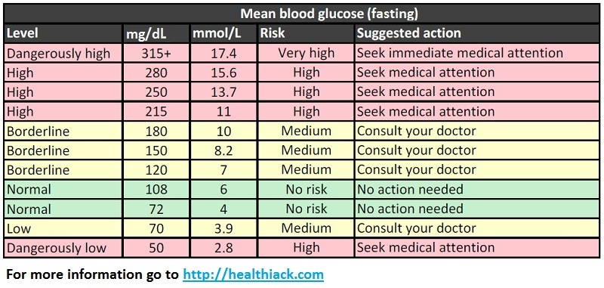

* 1. Blood pressure – It is necessary to monitor blood pressure especially for aged people, as well as one suffering from hypertension. We would design an electromechanical system, which would assist in the blood pressure measurement.

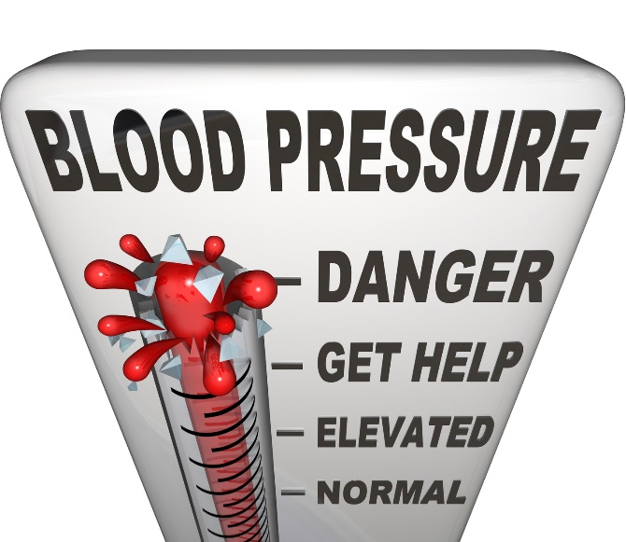

* 1. Body Weight – This can be measured easily through the devices available.
  2. Body Temperature – It can be measured through a normal mercury thermometer.
  3. Lung capacity – Asthmatic patients are often advised to keep track of their lung capacity. This can be designed using the principle behind a simple respiratory exerciser.
  4. (Provisional - If time permits) Eye testing (Determination of Lens power to correct Myopia) – It is one of the most common eye defect found commonly in 80 percent of the population. Therefore, we can create a mechanism comprising numerous lenses, which would be placed in the frame as required. That can help to test eyesight as our user reads text at particular distance.

## Designing and Manufacturing

Next, we will be concentrating on the final layout of the system with all the devices and mechanisms integrated such that it is easy to operate by a nonprofessional. We will a give detailed printed health report as well as store them in e-form systematically. After this we will begin the manufacturing of our first prototype.

## Testing and Improvements

After completing manufacturing we will start thorough testing of the prototype.

We would try to install the device in a health care centre for a day or two and take numerous measurements and see if the results are correct and consistent.

We would also take advice from doctors and technical persons to make the device better and more user-friendly.

For further improvement, we would try to make the devices more reliable and accurate.

**APPLICATION**

1. Urban people have an easy access to certain basic health monitoring machines. But people in the remote-areas do not have sufficient health check-up facilities and availability of doctors. They also can’t afford to go to private practitioners. This problem can be solved by our device that will be aimed at minimizing cost, maximizing efficiency of check-up and can solve issue of limited availability of doctors.
2. Development of a physical as well as electronic health card. A database can be created for analysing the health of a group of people as well as keeping track of patient’s health over a duration.
3. Further advancement can be made in our model in terms of incorporation of sophisticated devices/systems, hence increasing the accuracy of results. This machine can be used as a preliminary check-up device. This would help in the automation of the procedure thus reducing the requirement of man power, human errors and related problems that are frequently encountered.

**ESTIMATED BUDGET**

| S. No. | component | Estimated cost (INR) |
| --- | --- | --- |
| 1. | X Channel | 1000-1500 |
| 2. | Arduino | 500 |
| 3. | Respiratory exerciser | 500 |
| 4. | Blood pressure | 1500 |
| 5. | Blood glucose level monitoring | 2000 |
| 6. | Weighing machine | 1000 |
| 7. | Height measurement | 500 |
| 8. | Piston+Sensors+wires | 7000 |
| 9. | Miscellaneous | 6000 |
| optional | Eyes test lens | 4000 |
|  | Total | 20,500+4000 |

**FACILITIES REQUIRED**

1. We will be requiring 3D printing and circuit designing facilities like PCB printing, soldering etc.
2. Laser cutting and X-channel cutting facilities.
3. Bio-medics instruments and devices.
4. Acrylic sheet and its cutting.
5. Continuous interaction with a doctor and technical person.
6. Access to sensors and devices in Mechatronics lab

**REFERENCES**

1. <https://ihealthlabs.com/measuring-blood-pressure-daily-important-hypertension/>
2. [Dr. Morepen Gluco One Blood Sugar Meter BG-03 and test strip 25,50,75,100 combo | eBay](https://www.ebay.in/itm/232578998295?aff_source=Sok-Goog)
3. <https://www.ijser.org/researchpaper/Vein-Detection-System-using-Infrared-Light.pdf>
4. <http://www.diabetes.org/living-with-diabetes/treatment-and-care/blood-glucose-control/checking-your-blood-glucose.html?referrer=https://www.google.co.in/>
5. <https://www.brunet.ca/en/advices/the-importance-of-monitoring-blood-glucose-levels.html>
6. <http://healthmarketinnovations.org/sites/default/files/ACCESS_NSCPL_Case_study_Final%20%281%29.pdf>
7. <http://community.parkview.com/blog/parkview-health-2/how-to-measure-and-hit-a-healthy-blood-pressure>
8. <https://www.flipkart.com/dr-trust-precision-body-composition-monitor-fat-analyzer-weighing-scale/p/itmffc4nmkv5dugu?pid=WSLFFC2ZZF7DK8RP&start_url=BrowserLaunch_AMP>
9. <https://www.amazon.in/dp/B06X3Y6S4V?ref_=Oct_CANReleaseC_3150030031_3>
10. <https://www.youtube.com/watch?v=5LWM_5k8R1E>